**Assignment # 07**



**Spring 2024**

Submitted by:

**Waqas khan**

**Submitted to;**

**Syed Adeel shah**

Class Section: **A**

“On my honor, as student of University of Engineering and Technology, I have neither given nor received unauthorized assistance on this academic work.”

Student Signature: ______________

Month, Day, Year (Dec 08 2024)

Department of Computer Science

University of Engineering and Technology, Peshawar.

Task#01:

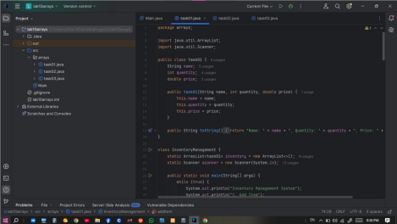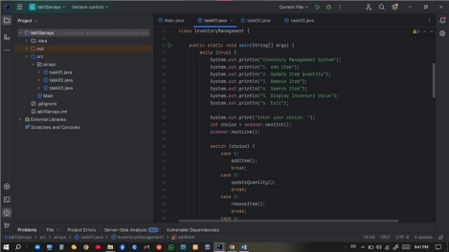



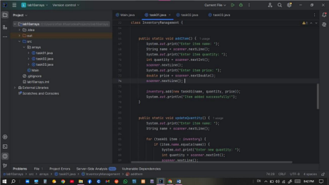

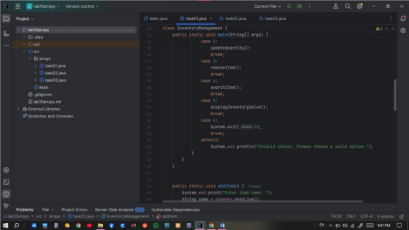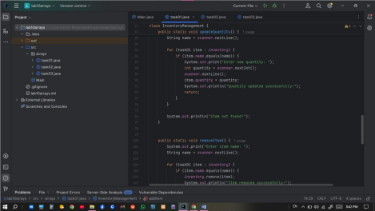

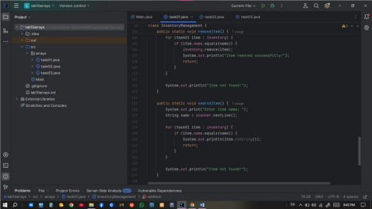

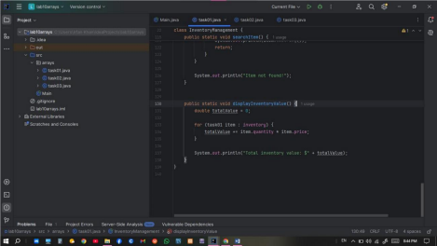

O utput: 

Task#02 :









Output:



Task#03 :















Output: